SIMATS ENGINEERING
ASSESSMENT TOOL 2
COURSE NAME: Operating Systems
COURSE CODE: CSA-0409
NAME: Sruthi Rithika P
REG NO: 192521407

COURSE OUTCOME COVERED
CO3: Evaluate memory management mechanisms such as linking, paging, and segmentation to determine their effectiveness for different system requirements
Assessment Tool Weightage: 30%

QUESTIONS: 10 Total Marks: 50

CASE STUDY:
1.
Based on the given system, explain in detail the concepts of logical address and physical address. Discuss how logical addresses generated by the CPU are translated into physical addresses before accessing memory. Illustrate your answer with a suitable example.

2.
Describe the complete address translation mechanism using base and limit registers in the given system. Explain how this method ensures memory protection and prevents processes from accessing unauthorized memory locations.

3.
Explain the concept of paging as implemented in the system. Describe how logical memory is divided into pages and mapped to physical frames. Discuss how paging helps in avoiding external fragmentation and improving memory utilization.

4.
Explain the structure and working of a page table in detail. Describe how page table entries are used to map logical addresses to physical addresses. Discuss the advantages and limitations of using page tables.

5.
Describe the working of the Translation Lookaside Buffer (TLB) in the given system. Explain how TLB reduces memory access time and improves overall system performance.

6.
Differentiate between TLB hit and TLB miss in detail. Explain how each case affects memory access time and system efficiency, and illustrate with an example.

7.
Explain how memory protection is achieved in the system using base/limit registers and access permissions. Discuss the importance of protection in a multi-user environment and explain what happens when a process violates access rules.

8.
Describe the concept of segmentation in detail. Explain how programs are divided into logical segments such as code, data, and stack, and discuss the benefits of segmentation over other memory management techniques.

9.
Explain the structure and functioning of a segment table. Describe how logical addresses are translated into physical addresses using segment number and offset.

10.
Compare and contrast paging and segmentation in detail. Discuss their differences in terms of memory allocation, fragmentation, flexibility, and performance.

11.
Explain the concept of virtual memory and its importance in modern operating systems. Describe how it allows execution of programs larger than the available physical memory.

12.
Describe the page fault handling process in detail. Explain each step involved when a page is not found in memory and how the operating system resolves the fault.

13.
Explain the need for page replacement algorithms in virtual memory systems. Describe the working of the FIFO page replacement algorithm with a suitable example.

14.
Discuss the concepts of linking and loading in detail. Explain the differences between static linking and dynamic linking, and describe how loading prepares a program for execution.

15.
Analyze how the combination of paging, segmentation, TLB, and virtual memory improves system performance and memory utilization in the given case study. Provide a detailed explanation.

RUBRICS FOR CALCULATION

Criteria | Weightage | Level 4 – Exemplary (5 Marks) | Level 3 – Proficient (4 Marks) | Level 2 – Developing (2–3 Marks) | Level 1 – Beginning (0–1 Mark)
Understanding of Case | 25 | Thorough understanding; clearly identifies all key issues | Good understanding with most issues identified | Basic understanding; some issues missed | Poor understanding; problem not identified correctly
Application of Concepts | 25 | Effectively applies relevant concepts to analyze the case deeply | Applies appropriate concepts with minor gaps | Limited application of concepts | Fails to apply relevant concepts
Analysis | 20 | In-depth analysis with strong reasoning and insights | Good analysis with logical reasoning | Basic analysis with limited depth | Weak or no analysis; lacks reasoning
Solution Design | 20 | Innovative, feasible solutions with strong justification | Logical solutions with adequate justification | Basic solutions with weak justification | Incorrect or no solution provided
Clarity | 10 | Clear, well-structured, and easy to understand | Organized and understandable presentation | Limited clarity and structure | Poor clarity; difficult to understand

ANSWERS
Q11) Virtual Memory – Concept and Importance
1. Introduction
Virtual memory is a memory management technique used by modern operating systems to provide programs with a large logical memory space, even when the available physical RAM is limited.
It uses a combination of main memory (RAM) and secondary storage (hard disk/SSD). The operating system temporarily moves less frequently used portions of programs from RAM to secondary storage and brings them back when required.
2. Concept of Virtual Memory
Virtual memory creates an abstraction in which each process gets its own large virtual address space.
The CPU generates logical (virtual) addresses, which are translated into physical addresses by the Memory Management Unit (MMU).
The virtual address space is usually divided into fixed-size pages, while physical memory is divided into corresponding frames.

With virtual memory:

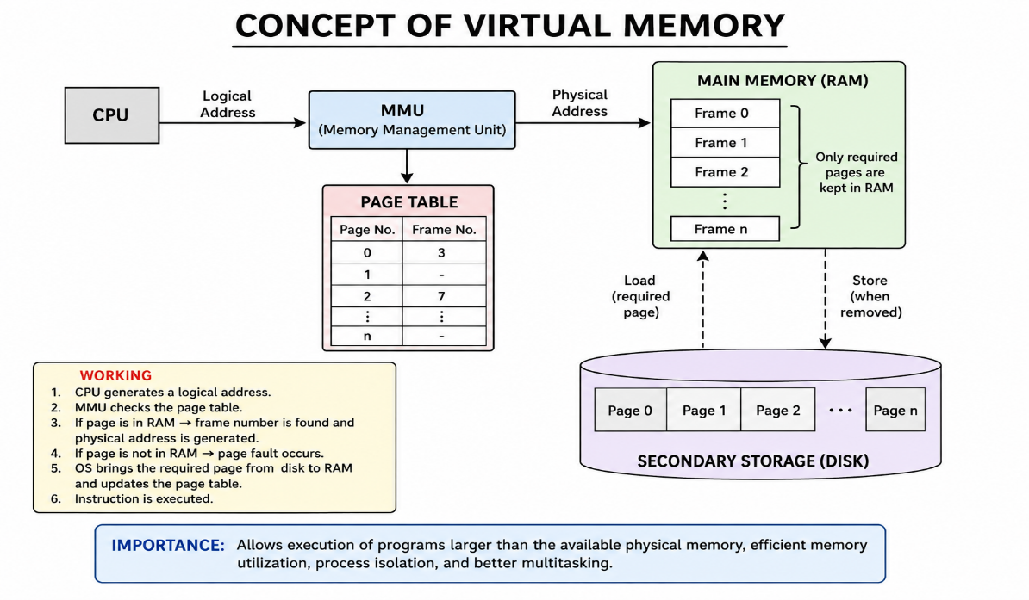
5. Page Replacement
If RAM is full and a required page needs to be loaded, the operating system must remove an existing page from RAM.
This is called page replacement.
Common page replacement algorithms include:
- FIFO (First-In, First-Out)
- LRU (Least Recently Used)
- Optimal Page Replacement
The selected page is moved to secondary storage if necessary, and the required page is loaded into RAM.

6. Importance of Virtual Memory
Virtual memory is important in modern operating systems for several reasons:
1. Executes Large Programs
It allows programs larger than available physical RAM to execute by keeping only the required portions in memory.
2. Efficient RAM Utilization
Only actively required pages need to remain in RAM, allowing memory to be used more efficiently.
3. Process Isolation
Each process gets its own virtual address space, preventing processes from directly accessing each other's memory.
4. Memory Protection
The operating system can control which pages a process is allowed to read, write, or execute.
5. Multitasking
Multiple programs can remain active because each program does not need to occupy its entire virtual address space in RAM at once.
6. Easier Program Development
Programmers can work with a large, continuous virtual address space without worrying about the exact physical locations of data in RAM.
7. Supports Memory Overcommitment
The operating system can provide processes with a virtual memory space larger than the available physical memory, as long as the working sets can be managed effectively.
7. Advantages
Advantage | Description
Large address space | Programs can use more memory than available RAM
Better RAM utilization | Only required pages are loaded
Process isolation | Processes have separate address spaces
Memory protection | Unauthorized memory access can be prevented
Multitasking | More programs can run simultaneously
Flexible memory management | Programs do not need contiguous physical memory

8. Disadvantages
Although virtual memory is useful, it also has some limitations:
- Page faults are slow because accessing disk/SSD is much slower than accessing RAM.
- Excessive page faults can cause thrashing, where the system spends more time moving pages than executing programs.
- Virtual memory requires additional memory-management overhead.
- It requires some amount of secondary storage space.

9. Conclusion
Virtual memory allows an operating system to provide programs with a large logical memory space even when physical RAM is limited. By dividing programs into pages and keeping only the required pages in RAM while storing inactive pages on secondary storage, a program larger than the available physical memory can be executed. It is therefore an essential feature of modern operating systems, supporting large applications, multitasking, memory protection, process isolation, and efficient memory utilization.
Q12) Page Fault Handling Process
1. Introduction
A page fault occurs when a process tries to access a page that is part of its virtual address space but is not currently present in physical memory (RAM).
The operating system handles the page fault by locating the required page in secondary storage, loading it into RAM, updating the page table, and restarting the interrupted instruction.
2. Page Fault Handling – Steps
Step 1: CPU Generates a Logical Address
The CPU generates a logical (virtual) address while executing an instruction.
The address is divided into:
- Page number
- Offset
The page number is used to locate the required page in the page table.
Step 2: MMU Checks the Page Table
The Memory Management Unit (MMU) checks the page table to determine whether the required page is currently available in RAM.
The page table contains a valid/invalid bit:
- Valid (1): Page is present in RAM.
- Invalid (0): Page is not currently in RAM.
If the page is present, normal memory access continues.
Step 3: Page Fault Occurs
If the page table indicates that the required page is not in RAM, the hardware generates a page-fault trap.
Control is transferred from the currently running process to the operating system.
CPU
↓
Logical Address
↓
MMU
↓
Page Table
↓
Page not in RAM
↓
PAGE FAULT
↓
Operating System
Step 4: Operating System Checks the Access
The operating system checks whether the memory reference is legal.
- If the address is invalid or the process does not have permission to access it, the OS terminates the process or generates an appropriate protection error.
- If the reference is valid, the OS continues handling the page fault.
Step 5: Find a Free Frame
The operating system searches RAM for a free memory frame.
If a free frame is available, it can be used to load the required page.
If no free frame is available, the OS must select an existing page to remove using a page replacement algorithm, such as:
- FIFO
- LRU
- Optimal
Step 6:Update the Page Table
After loading the page into RAM, the OS updates the page table.
It records:
- The new frame number
- The page's valid bit
- Other required information such as protection or status bits
The page is now marked as present in memory.
Step 7: Restart the Interrupted Instruction
The instruction that caused the page fault is restarted.
This time, the required page is available in RAM, so the MMU can translate the logical address into a physical address successfully.
The CPU then accesses the required data or instruction.
3. Complete Page Fault Flow
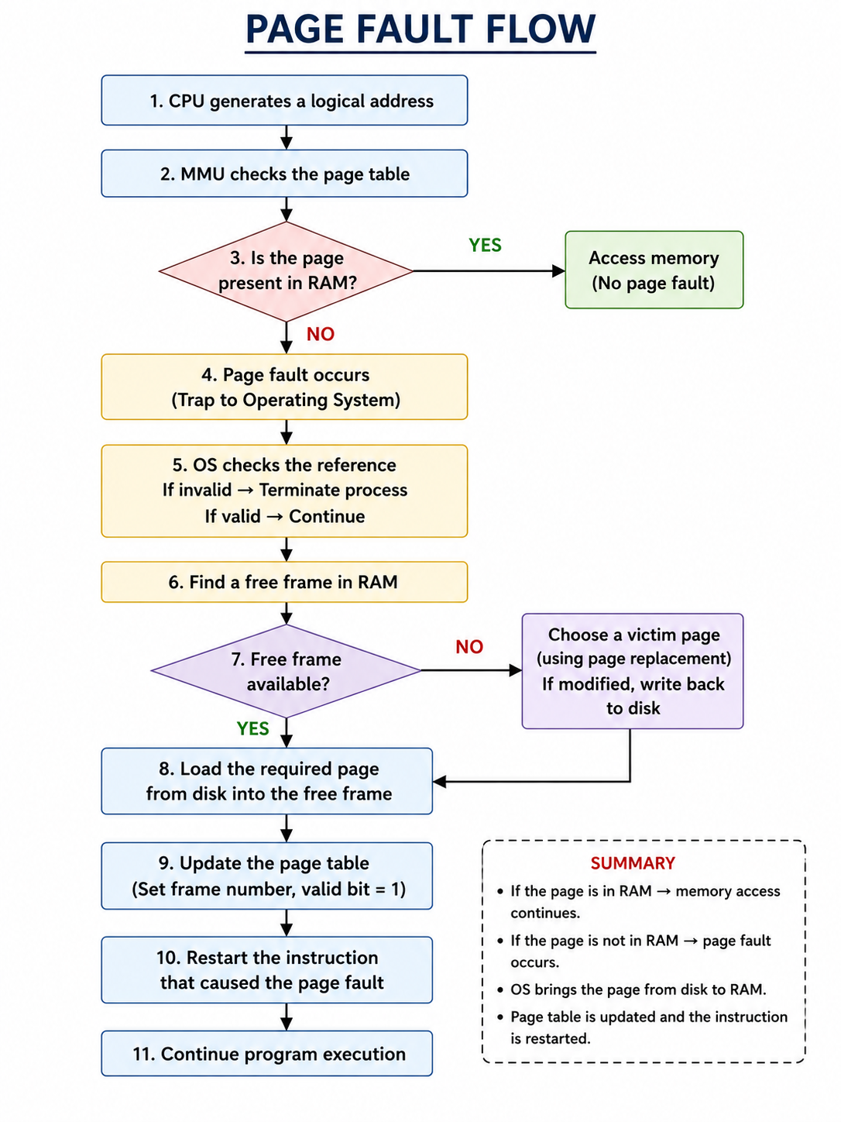
4. Example
Assume a process requires Page 5, but Page 5 is currently stored on the disk and not in RAM.
- CPU generates an address belonging to Page 5.
- MMU checks the page table.
- Page 5 has an invalid bit, indicating that it is not in RAM.
- A page fault occurs.
- OS verifies that the address is valid.
- OS finds a free frame, say Frame 3.
- Page 5 is loaded from disk into Frame 3.
- Page table is updated:
Page | Frame | Valid
5 | 3 | 1
- The interrupted instruction is restarted.
- The CPU now accesses Page 5 successfully through Frame 3.

5. Important Points
- A page fault does not necessarily mean an error. It is a normal part of virtual memory management.
- It occurs when the required page is not currently in RAM.
- The OS brings the page from secondary storage into RAM.
- If RAM is full, a page replacement algorithm may be required.
- Page faults are relatively expensive because disk/SSD access is much slower than RAM access.
- Too many page faults can cause thrashing, which significantly reduces system performance.

6. Conclusion
Page fault handling is an essential part of virtual memory management. When a required page is absent from RAM, the hardware generates a page-fault trap and transfers control to the operating system. The OS validates the request, finds or creates a memory frame, loads the required page from secondary storage, updates the page table, and restarts the interrupted instruction. Thus, page fault handling allows programs to execute efficiently even when their complete memory requirements cannot fit into physical RAM.
Q13) Page Replacement Algorithms and FIFO
1. Introduction
In a virtual memory system, a page fault occurs when the CPU requests a page that is not currently present in RAM. The operating system must bring that page from secondary storage into memory.
If all memory frames are already occupied, the OS must decide which existing page should be removed to make space for the required page. This decision is made using a page replacement algorithm.

2. Need for Page Replacement Algorithms
Page replacement algorithms are required for the following reasons:
- Limited Physical Memory
RAM has limited capacity, while programs may require much more memory.
- Handling Page Faults
When a required page is not in RAM, another page may need to be removed to load it.
- Efficient Memory Utilization
They ensure that available memory frames are used effectively.
- Reducing Page Faults
A good replacement algorithm reduces the number of page faults.
- Improving System Performance
Fewer page faults mean fewer slow disk/SSD accesses and better overall performance.
- Supporting Multiprogramming
Multiple processes can share limited physical memory efficiently.

3. FIFO Page Replacement Algorithm
FIFO (First-In, First-Out) is one of the simplest page replacement algorithms.
The basic principle is:
The page that entered memory first is removed first.
It maintains the pages in the order in which they were loaded into memory, usually using a queue.
Working
- When a page is requested, check whether it is already in RAM.
- If it is present, there is no page fault.
- If it is absent, a page fault occurs.
- If a free frame is available, load the page into it.
- If all frames are full, remove the page that has been in memory for the longest time.
- Insert the newly requested page at the end of the queue.
4. Suitable Example
Consider:
- Number of frames = 3
- Reference string = 1, 2, 3, 4, 1, 5
Initially, all frames are empty.

Step 1: Page 1
- Memory is empty.
- Page 1 is loaded.
- Fault = 1.
[1] [-] [-]
Step 2: Page 2
- Page 2 is not in memory.
- Free frame is available.
- Page 2 is loaded.
[1] [2] [-]
Step 3: Page 3
- Page 3 is not in memory.
- Free frame is available.
- Page 3 is loaded.
[1] [2] [3]
Step 4: Page 4
- All frames are full.
- Page 1 entered first, so FIFO removes Page 1.
- Page 4 is loaded.
[4] [2] [3]
Step 5: Page 1
- Page 1 is no longer in memory.
- The oldest page currently in memory is Page 2.
- FIFO removes Page 2 and loads Page 1.
[4] [1] [3]

Step 6: Page 5
- Page 5 is not in memory.
- The oldest page is Page 3.
- FIFO removes Page 3 and loads Page 5.
[4] [1] [5]
Total Page Faults
Total page faults = 6

5. FIFO Queue Representation
The FIFO process can be represented as:
Page 1 → Page 2 → Page 3
↑ ↓
Oldest Newest

When Page 4 arrives:
Page 1 is removed

Page 2 → Page 3 → Page 4
↑ ↓

When Page 1 arrives:
Page 2 is removed

Page 3 → Page 4 → Page 1
Thus, pages are removed according to their arrival order.

6. Advantages of FIFO
- Simple and easy to implement.
- Requires minimal overhead.
- Uses a simple queue structure.
- Easy to understand and manage.
7. Disadvantages of FIFO
- It does not consider how frequently a page is used.
- An important frequently used page may be removed simply because it is old.
- It can result in a large number of page faults.
- FIFO can suffer from Belady's anomaly, where increasing the number of frames can sometimes increase the number of page faults.

8. Conclusion
Page replacement algorithms are essential when all available memory frames are occupied and a new page must be loaded. FIFO is a simple page replacement algorithm that removes the page that has been in memory for the longest time. Although it is easy to implement, it may not always provide good performance because it ignores the actual usage pattern of pages. More advanced algorithms such as LRU and Optimal can generally provide better page replacement decisions.
Q14) Linking and Loading
1. Introduction
When a program is written in a high-level language such as C or C++, it cannot be directly executed by the CPU. The source program must go through several stages such as compilation, linking, and loading before execution.
The main purpose of:
- Linking is to combine program modules and resolve references to functions and variables.
- Loading is to place the executable program into main memory and prepare it for execution
Linking
Linking is the process of combining one or more object files and library files to create a single executable program.
For example, consider a C program that uses the printf() function. The compiled object file contains a reference to printf(). The linker connects this reference with the appropriate library implementation.
Main Functions of a Linker
- Combines object files
- Resolves external references
- Links library functions
- Assigns addresses to program sections
- Produces the executable file
Example
Suppose a program consists of:
main.c
↓
main.o

math.c
↓
math.o
The linker combines:
main.o + math.o + required libraries
↓
Executable File
3. Types of Linking
There are two major types:
- Static Linking
- Dynamic Linking
4. Static Linking
In static linking, the required library code is copied directly into the executable file during the linking stage.
For example:
Program Object File
+
Library Code
↓
Linker
↓
Complete Executable
The executable contains the required library functions, so they do not need to be provided separately at run time.
Example
If a program uses a mathematical library function, the required code from the library can be included inside the executable.
Advantages
- Program can run without depending on external library files at runtime.
- Execution can be slightly faster because library references are already resolved.
- The executable is self-contained.
Disadvantages
- Executable files are larger.
- The same library code may be duplicated in many programs.
- Updating a library requires programs to be re-linked to include the new version.
5. Dynamic Linking
In dynamic linking, library code is not completely copied into the executable during linking. Instead, the required library is connected to the program at load time or during execution.
Program
+
Dynamic Library
↓
Dynamic Linker
↓
Execution
Common examples include shared libraries such as:
- .dll files in Windows
- .so files in Linux
Advantages
- Smaller executable files.
- Library code can be shared by multiple programs.
- Libraries can be updated separately.
- Saves memory because the same shared library can be used by multiple processes.
Disadvantages
- Program depends on the required library being available.
- There can be additional overhead when libraries are loaded or linked.
- Incompatible library versions can cause execution problems.

Loading
Loading is the process of placing the executable program into main memory (RAM) and preparing it for execution.
The component responsible for this process is called the loader.
After linking produces an executable file, the loader performs the necessary operations before the CPU starts executing the program.

8. Functions of a Loader
1. Allocate Memory
The loader determines how much memory is required for:
- Code/Text
- Data
- Heap
- Stack
It allocates the required memory for the process.
2. Load Program into Memory
The executable's instructions and data are copied from secondary storage into the appropriate memory locations.
3. Address Relocation
The program may not always be loaded at the same physical memory address.
The loader adjusts addresses so that the program can execute correctly at its assigned memory location.
4. Resolve Dynamic References
For dynamically linked programs, the loader or dynamic linker loads the required shared libraries and resolves references to them.
5. Set Up Execution Environment
The operating system prepares:
- Stack
- Heap
- Registers
- Program counter
- Required process information
6. Transfer Control to Program
Finally, the loader sets the program counter to the program's starting address and transfers control to the program.
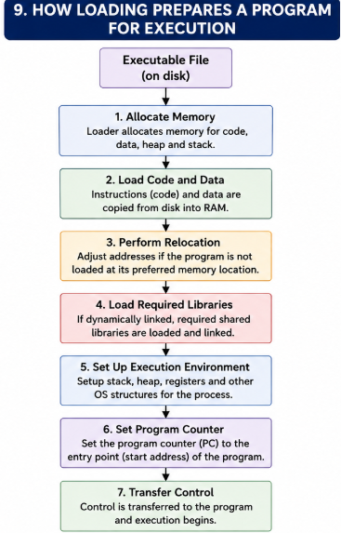

Conclusion
Linking and loading are essential stages between compilation and program execution. Linking combines object files and resolves references to libraries, producing an executable file. It can be performed through static linking, where library code is included in the executable, or dynamic linking, where libraries are linked at load time or during execution.
Loading then prepares the executable for execution by allocating memory, loading code and data, performing relocation, resolving dynamic libraries, setting up the process environment, and transferring control to the program. Together, linking and loading ensure that a compiled program can be correctly executed by the operating system.

Q15) Combination of Paging, Segmentation, TLB and Virtual Memory
1. Introduction
Modern operating systems use several memory-management techniques together to improve memory utilization, execution speed, protection, and system performance.
The four important techniques are:
- Paging
- Segmentation
- Translation Lookaside Buffer (TLB)
- Virtual Memory
When these techniques work together, programs can use a large logical address space while the operating system efficiently manages limited physical RAM.

2. Paging
Paging divides the logical address space into fixed-size blocks called pages and physical memory into fixed-size blocks called frames.
When a program needs a page, the operating system loads it into an available frame.
Example
Suppose:
- Program size = 8 GB
- Available RAM = 4 GB
The entire program does not have to be loaded into RAM. Only the currently required pages are loaded.
Virtual Memory
┌────┬────┬────┬────┬────┬────┐
│ P0 │ P1 │ P2 │ P3 │ P4 │ P5 │ ...
└────┴────┴────┴────┴────┴────┘
│ │
▼ ▼
RAM
┌────┬────┬────┬────┐
│ F2 │ F5 │ F1 │ F7 │
└────┴────┴────┴────┘
Benefits
- Reduces external fragmentation.
- Allows non-contiguous memory allocation.
- Improves RAM utilization.
- Supports virtual memory.

3. Segmentation
Segmentation divides a program according to its logical components rather than fixed-size blocks.
Typical segments include:
- Code segment
- Data segment
- Stack segment
- Heap segment
For example:
Program
│
├── Code
├── Data
├── Heap
└── Stack
Each segment can have different size and protection permissions.
Benefits
- Provides logical organization of programs.
- Supports memory protection.
- Allows sharing of selected program segments.
- Makes it easier to control access to code and data.

4. TLB (Translation Lookaside Buffer)
The TLB is a small, high-speed cache inside or close to the MMU that stores recently used page-table entries.
Without a TLB, every virtual address translation may require an additional page-table memory access.
Without TLB

CPU
↓
Page Table
↓
Physical Address
↓
RAM
This requires additional memory access for address translation.
With TLB
CPU
↓
TLB
↓
Physical Address
↓
RAM
If the required page-table entry is present in the TLB, the physical frame number can be obtained quickly.

5. Virtual Memory
Virtual memory allows a program to use a logical address space larger than the available physical RAM.
Pages that are not currently required can remain on secondary storage.
When a required page is absent from RAM, a page fault occurs and the operating system loads the page from disk/SSD.

Virtual Address Space
│
▼
TLB
│
▼
Page Table
│
▼
RAM
│
│ Page Fault
▼
Disk / SSD
Benefits
- Allows large programs to execute.
- Supports multitasking.
- Improves memory utilization.
- Provides process isolation.
- Allows only required pages to occupy RAM.
Performance Improvement
1. Faster Address Translation
The TLB stores frequently used page-table entries. A TLB hit avoids the need to access the page table in RAM, significantly reducing address-translation overhead.

2. Better RAM Utilization
Paging and virtual memory ensure that only required portions of programs are kept in RAM.
For example, if a 10 GB program is running on a system with 4 GB RAM, the complete program does not need to be loaded into RAM simultaneously.
3. Reduced Memory Waste
Paging allows pages to occupy any available frame rather than requiring one large contiguous memory block.
4. Improved Protection
Segmentation provides logical boundaries between code, data, stack, and other areas. Access permissions can be associated with these areas.
Paging also supports protection bits such as:
- Read
- Write
- Execute
5. Efficient Multitasking
Virtual memory allows several processes to maintain large address spaces while only their active portions occupy physical RAM.
6. Reduced Translation Overhead
The TLB keeps frequently used translations close to the CPU, reducing repeated page-table lookups.

8. Example Case Study
Consider a system running three applications:
- Application A: 6 GB virtual memory
- Application B: 4 GB virtual memory
- Application C: 3 GB virtual memory
- Physical RAM: 8 GB

The total virtual memory requirement is:
6 + 4 + 3 = 13 GB
However, physical RAM is only 8 GB.
Virtual memory allows all three applications to run because only their currently active pages need to be in RAM.
Working
- Each process receives its own virtual address space.
- Segmentation logically separates code, data, stack, and other regions.
- Paging divides these regions into pages.
- Required pages are loaded into available RAM frames.
- The TLB stores frequently used page-to-frame mappings.
- If a required page is not in RAM, a page fault occurs.
- The OS loads the page from secondary storage.
- The page table and TLB are updated.
- Execution continues.
Thus, the system can run programs whose combined virtual memory requirements exceed physical RAM.
Conclusion
The combination of paging, segmentation, TLB, and virtual memory provides an efficient and flexible memory-management system.
- Paging improves physical memory utilization by allowing non-contiguous allocation.
- Segmentation provides logical organization, protection, and controlled sharing.
- TLB significantly speeds up virtual-to-physical address translation.
- Virtual memory allows programs larger than physical RAM to execute by keeping only required portions in memory.

